***SOFTWARE PROJECT FINAL REPORT***

**Date: 12/07/2023**

Presenters: Siddarth Reddy Chinthalapani - 2845810

Pramodh Bakkera - 2834840

Ram prasad Gummadi – 2873418

**Table of Contents**

|  |  |  |
| --- | --- | --- |
| **SNO** | **TOPIC** | **Page No** |
| 1 | Introduction: Purpose and Scope | 3 |
| 2 | Introduction: Structure of the Document | 3 |
| 3 | Project Management Plan | 4 |
| 4 | Risk Analysis | 6 |
| 5 | Hardware and Software Resource Requirements | 6 |
| 6 | Requirement Specifications | 7 |
| 7 | Architecture | 8 |
| 8 | Technology, software, and hardware used | 10 |
| 9 | Design | 11 |
| 10 | Components design | 12 |
| 11 | Database design | 13 |
| 12 | Rationale for your detailed design mode | 14 |
| 13 | A complete list of system test cases | 15 |
| 14 | Traceability of test cases to use cases | 17 |
| 15 | Techniques used for test case generation | 17 |
| 16 | Test results and assessments (how good are your test cases? How good is your software?) | 18 |
| 17 | Defects reports | 19 |
| 18 | Conclusions | 19 |

**List of Figures**

|  |  |  |
| --- | --- | --- |
| **FIGURE_NO** | **NAME** | **PAGE No** |
| Fig 1 | Structure of the Document | 3 |
| Fig 2 | Project Organization | 4 |
| Fig 3 | Lifecycle Model | 5 |
| Fig 4 | Graphic use case | 8 |
| Fig 5 | Architectural model | 9 |
| Fig 6 | Sequence diagram for Login and Register | 9 |
| Fig 7 | Sequence diagram for Category and View the Review comments & Health Conditions | 10 |
| Fig 8 | Login Page | 11 |
| Fig 9 | Register page | 11 |
| Fig 10 | Home page | 12 |
| Fig 11 | Static models | 12 |
| Fig 12 | Dynamic models | 13 |

**List of Tables**

|  |  |  |
| --- | --- | --- |
| **Table NO** | **NAME** | **PAGE No** |
| Table NO 1 | Abbreviations | 4 |
| Table NO 2 | Risk Analysis | 6 |
| Table NO 3 | Schedule | 7 |
| Table NO 4 | Database Design | 13 |
| Table NO 5 | Traceability Requirement Matrix | 14 |
| Table NO 6 | Test Case Register 1 | 15 |
| Table NO 7 | Test Case Register 2 | 15 |
| Table NO 8 | Test Case Food Review 1 | 15 |
| Table NO 9 | Test Case Food Review 2 | 15 |
| Table NO 10 | Test Case User Login 1 | 16 |
| Table NO 11 | Test Case User Login 2 | 16 |
| Table NO 12 | Test Case User Login 3 | 16 |
| Table NO 13 | Test Case User Login 4 | 16 |
| Table NO 14 | Traceability of test cases | 17 |
| Table NO 15 | Test Results | 18 |
| Table NO 16 | Assessments | 18 |
| Table NO 17 | Defect Report | 19 |

1. **Introduction**

1.1. **Purpose and Scope**

**Purpose:**

This software will help the to know the food review and health benefits for the category-based products based on the ingredients, for this users needs to register themselves and login into the application with the details

**Scope:**

Users can register themselves by using register us link in the login page, so that they can view the food review based on products list and ingredients once user login into the application.

**1.2. Product Overview** (including capabilities, scenarios for using the product, etc.)

It is meant to delineate the features of the new application such as register us, Login Page and Food review page which help the to know the food review and health benefits for the category-based products based on the ingredients, for this user needs to register themselves and login into the application with the details.

* Login Page --- User can login into the application
* Register Page---User need to register themselves to view the food review and comments
* Food Review--- To view the food review either Good or Bad based on Product and Ingredients

**1.3. Structure of the Document**

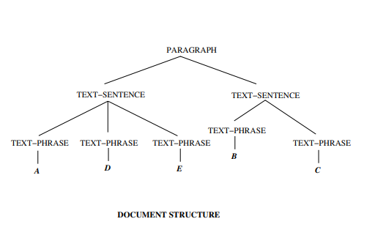

**Fig 1: Structure of the Document**

**1.4. Terms, Acronyms, and Abbreviations**

**Terms**

1. Login Page- Its was a page for user to login into the application.
2. Register Us-Its was a page to register themselves by the users to get use of the application.
3. Username: Its was email id used while registering

**Abbreviations**

|  |  |
| --- | --- |
| SRS | Software Requirement Specification. |
| SDS | Software Design Specification |
| DFD | Data Flow Diagram. |
| DB | Database |

**Table No: 1 Abbreviations**

**Acronyms**

✓Login Button: Used for the login

✓Register Button: Used for the registering

✓Category: Its was Food Type either Good or Bad

✓Review: Its was Food review for the selected Ingredients

**2. Project Management Plan**

**2.1. Project Organization**

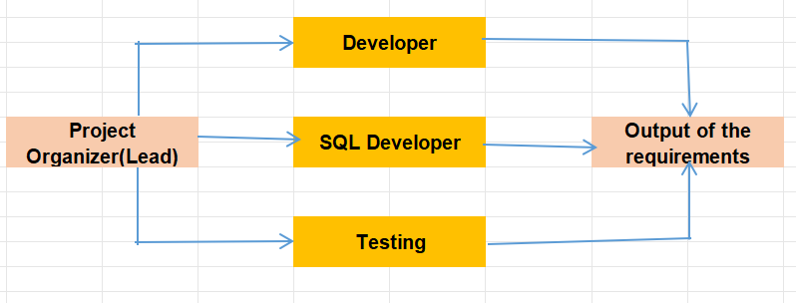

**Fig 2: Project Organization**

2.2. **Lifecycle Model Used**

Software Development Life Cycle (also called SDLC Models ) is a workflow process which defines the core stages and activities of development cycles or A framework that describes the operations performed at each phase of a software development project.

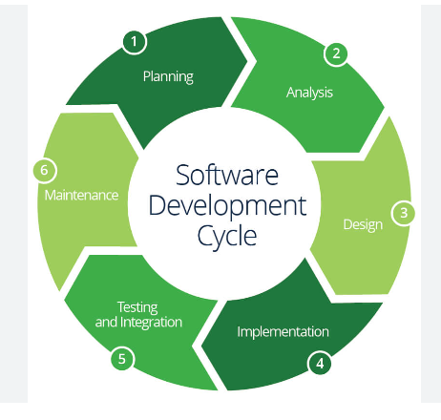

**Fig 3:** **Lifecycle Model**

1. **Planning:** Initially, team has planned to implement the register us page with the minimum fields required
2. **Analysis:** Started our analysis by using what are the required fields for the register page and login page, review page and gathering of the category list with the food review along with health benefits which needs to be inserted in the Database.
3. **Design:** Initially we started designing of the documents and code logic things for the register us page, login page and food review page
4. **Implementation:** Started the code of the register us page and then integrated the login details while the user tried to login into the application and checking of the food review page by selecting the category present in the list which was inserted in the Database
5. **Testing & Integration:** Testing of the register us page by checking the validations and alerts without proper data and doing of the integration testing once for all the requirements of the website.
6. **Maintenance:** Running of the application from the tomcat server to check frequently whether running or not

2.3. **Risk Analysis**

This section discusses project risks and the approach to managing them.

Project risks are events or circumstances that can potentially have a negative impact on a project's objectives, such as its scope, schedule, budget, or quality. Identifying and assessing project risks is a crucial part of project management.

* Scope Creep
* Resource Constraints
* Schedule Delays
* Quality Issues
* Technical Challenges
* Communication Breakdown

|  |  |  |  |
| --- | --- | --- | --- |
| **Name of risk** | **probability** | **impact** | **RM3 pointer** |
| Scope Creep | less | Impact on Design of the requirement | Initial |
| Resource Constraints | less | Impact on Schedule Timings | Optimized |
| Schedule Delays | medium | Impact on Timely Deliverable | Defined |
| Quality Issues | medium | Impact on Output of the requirement | Optimized |
| Technical Challenges | medium | Impact on Proper Coding & testing | Initial |
| Communication Breakdown | medium | Impact on Design of the requirement | Initial |

**Table No:2 Risk Analysis**

**2.4. Hardware and Software Resource Requirements**

**Hardware Requirements**

Laptop/Desktop PC-Purpose for users submitting of the request us page by filling the required fields in the application.

**Software Resource Requirements**

**External machine interfaces**

1.Operating System: Windows 11

2. Tomcat Server and NetBeans

4.My SQL Server Management Studio

5.Java Development Toolkit.

**External system interfaces**

Users needs to have stable internet connection to access the application and requester details to submit the request

**2.5. Deliverables and schedule**

Project Plan – 09/21/2023

Software Requirement Specification (SRS) – 10/05/2023

Software Design Specification (SDS) – 10/19/2023

Initial version of software – 11/02/2023

Test plan – 11/09/2023

Project Deliverables – 12/07/2023

Project presentation and demonstration(Final Project) --12/5/2023-12/7/2023

|  |  |  |  |  |
| --- | --- | --- | --- | --- |
| **Feature** | **Dev Start Date** | **Dev End Date** | **QA Start Date** | **QA End Date** |
| Register US | 11-20-2023 | 11-20-2023 | 11-21-2023 | 11-21-2023 |
| Login Page | 11-22-2023 | 11-22-2023 | 11-23-2023 | 11-23-2023 |
| Food Review Page | 12-01-2023 | 12-01-2023 | 12-02-2023 | 12-02-2023 |
| Drop-downs Binding in the DB | 12-02-2023 | 12-02-2023 | 12-03-2023 | 12-03-2023 |

**Table No:3 Schedule**

**3. Requirement Specifications**

**3.1. Stakeholders for the system**

In a project, there are both internal and external stakeholders. Internal stakeholders may include top management, project team members, your manager, peers, resource manager, and internal customers.

**Stakeholders for the system:**

* End Users
* Internal Team who gives the requirements
* Project Management Team

**3.2. Use cases**

3.2.1. Graphic use case model

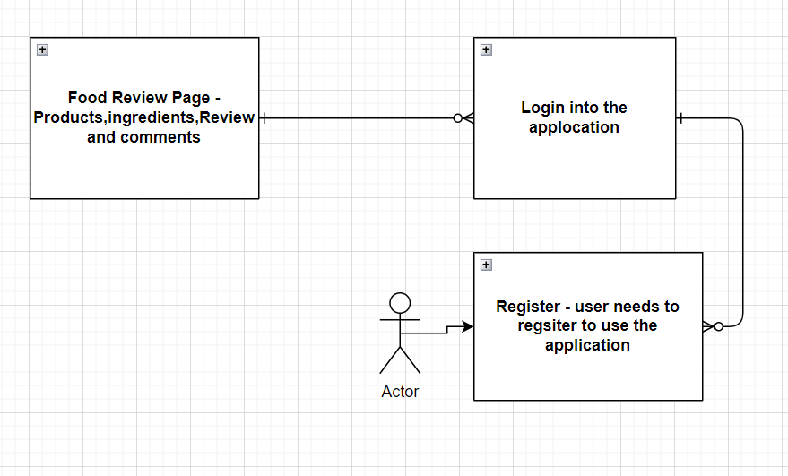

**Fig 4 Graphical Use Case**

3.2.2. Textual Description for each use case

**1.Register:** If customer wants to know food review for the products listed in the application, he/she needs to register into the application with required details.

**2.Login:** Customer needs to login to access the application with valid Customer ID and Password.

**3.Food Review Page:** Customer can select the product and related ingredients for review either Good or Bad and its related comments

**4.Logout:** User can logout after usage of application.

**3.3. Rationale for your use case model**

Graphic use case models offer a visual blueprint, enhancing understanding

of system functionality and facilitating clear communication among stakeholders,

aiding in requirement validation and efficient system design.

**3.4. Non-functional requirements**

Design of the application should be good and to store the requester details full secure.

**4. Architecture**

**4.1. Architectural style(s) used**

The Architectural Style are:

**Layered Architecture:** Organizes the system into layers, each responsible for specific functionality. Common layers include presentation, business logic, and data storage. This approach enhances modularity and maintainability.

**4.2. Architectural model (includes components and their interactions)**

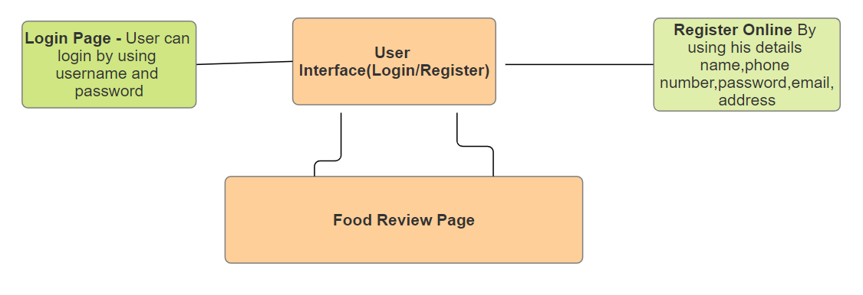

**Fig 5 Architectural model**

**Description for Components**

Major components in our web application are:

* Login/Register
* Select the Products for food review

**4.2.1 Login/Register**

**4.2.1.1 Login**

User must have their own valid credentials to access the system.

**4.2.1.2 Register**

User must provide basic required details to register into the system.

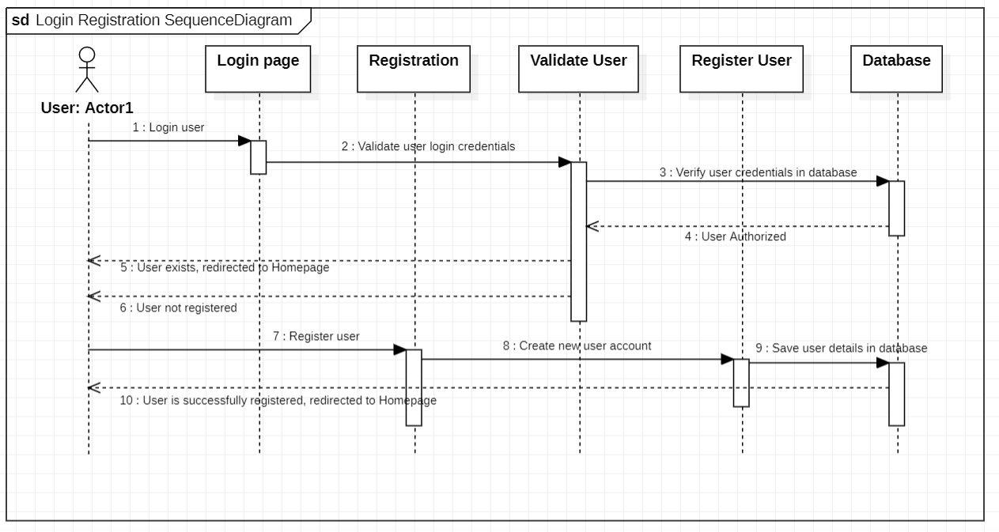

**Fig 6 Sequence diagram for Login and Register**

**4.2.2 Products**

**4.2.2.1 Select for Categories and view the Review/Health Conditions**

User can select the category from the list and can view the comments and health conditions based on category

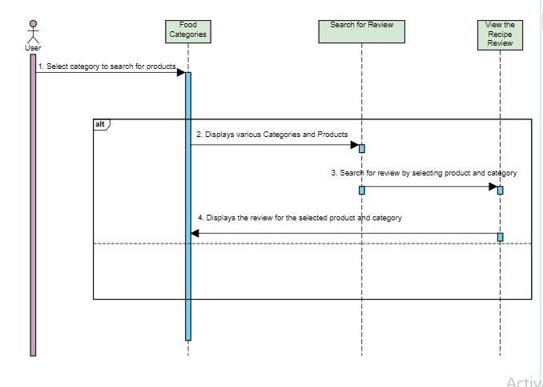

**Fig 7 Sequence diagram for Category and View the Review comments & Health Conditions**

**4.3. Technology, software, and hardware used**

**Technology:**

**Software Programming Languages:** Java, JavaScript

**Development Methodologies:** Waterfall for project management and development processes.

**Databases:** MySQL

**Networking:** HTTP/HTTPS protocols for communication.

**Hardware:** Desktops/Laptops: Windows/Apple

**4.4. Rationale for your architectural style and model**

JSP and Servlets: Enable robust server-side processing and seamless integration with Java-based systems, ensuring efficient and scalable web application development.

JavaScript: Empowers dynamic client-side interactions, offering enhanced user experience and leveraging a rich ecosystem of libraries and frameworks for versatile web development.

**5.Design**

**Description of the user interface**

Below are the images of Food Review Login, Register and Select the Category/Product to view the review and health conditions for the selected product

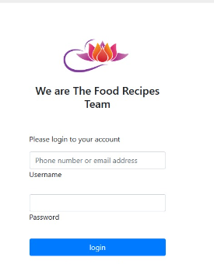

**Fig 8: Login Page**

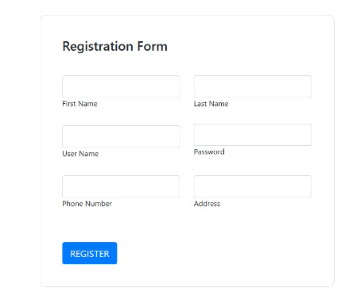

**Fig 9: Register page.**

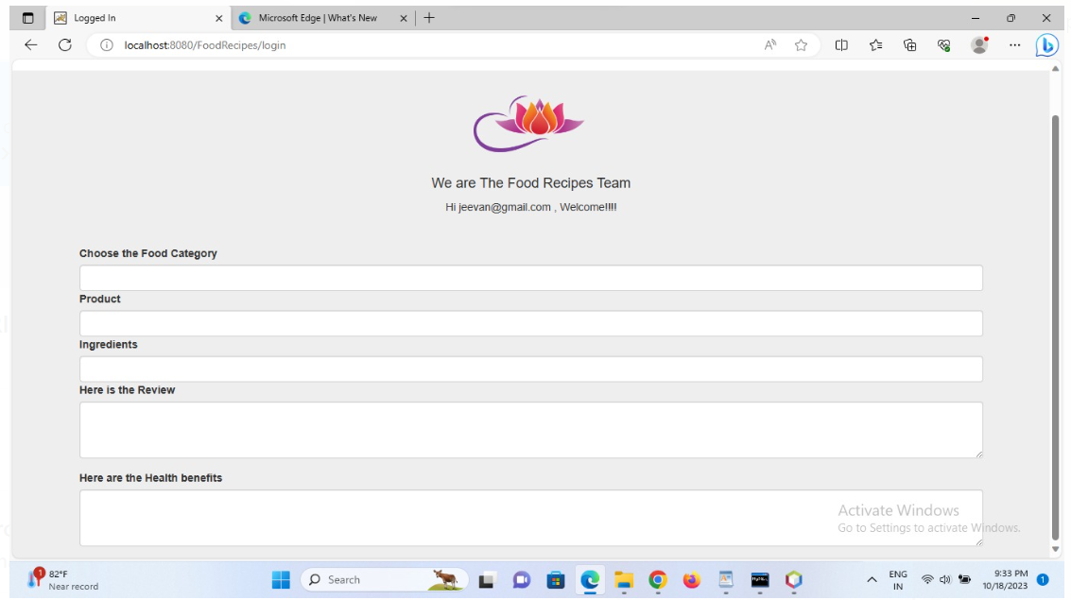

**Fig 10: Home page**

**5.2. Components design (static and dynamic models of each component)**

**Static models**

**Class diagram:**

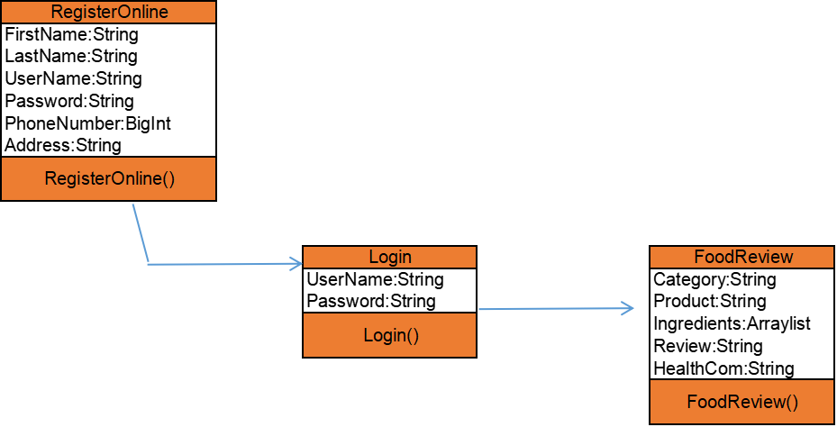

**Fig 11: Static Model**

**Dynamic models**

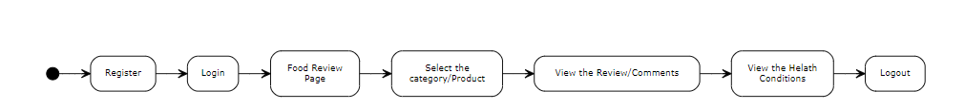

**Fig 12: Dynamic Model**

**5.3. Database design**

A description of all data structures and databases.

**5.1 Data structures**

Data structured that are available to major portions of the architecture are described as shown below such as Customer ID: Int, First Name: String, Last Name: String, Address 1: String , City: String …….for the users and Product ID: Int , Product Name: String , Ingredients ID : Int …. for the Food Category

**5.2 Database description**

Database(s) created as part of the application is(are) described, below are the tables designed for application.

Users, Food Category

|  |  |
| --- | --- |
| **Users** | **Food Category** |
| Customer ID: Int | Product ID: Int |
| First Name: String | Product Name: String |
| Last Name: String | Ingredients ID: Int |
| Address 1: String | Ingredients name: String |
| City: String | Review:  String |
| ZIP Code: Int | Comments: String |
| Country: String | Category Name: String |
| Mobile Number: BigInt |  |
| Email: String |  |
| Password: String |  |

**Table No:4 Database Design**

**5.4. Rationale for your detailed design models**

Reliability and Performance: MySQL ensures reliable data storage and retrieval, offering optimized performance even with complex queries between two tables, ensuring quick data access and manipulation.

Scalability and Relationship Management: Facilitating efficient management of relationships between tables, MySQL's relational database model allows for scalable growth, maintaining data integrity and enabling smooth expansion as the project evolves.

**5.5. Traceability from requirements to detailed design models.**

|  |  |  |  |  |  |
| --- | --- | --- | --- | --- | --- |
| **Use Case** | **Requirement Number** | **Requirement Description** | **Test Case** | **Design Component / Module** | **Comments** |
| Registering of the User | FR_001 | End Users need to register themselves for accessing the Food review Page | TRC_001 | Register Page-First Name, Last Name, Username,Password,Phone Number,Address |  |
| Login into the Application | FR_002 | Registered Users needs to login into the application with their details such as username & password to access the food review page | TRC_002 | Login Page -Username , Password |  |
| Food Review Page | FR_003 | Users can view the review of the food products based on category, ingredients, and comments | TRC_003 | Home Page-Category drop-down, Products Drop down, Inc regents Drop down, Review/Comments |  |

**Table No:5 Traceability Requirement Matrix**

**6. Test Management**

**6.1. A complete list of system test cases**

**Test cases for User Registration:**

|  |  |
| --- | --- |
| ID | Register_1 |
| Test Input | Valid details like FirstName, LastName, Username/Email, Password,Phone Number,Address |
| Expected Output | User should be able to register into the application |
| Description | User must enter his/her valid details to register into the application. |

**Table No:6 Test Case Register 1**

|  |  |
| --- | --- |
| ID | Register_2 |
| Test Input | FirstName, LastName, Username/Email, Password,Phone Number,Address |
| Expected Output | Error message is shown to fill all the fields. |
| Description | If user does not enter any one of required fields, error message is shown to fill all the details. |

**Table No:7 Test Case Register 2**

**Test cases for Food Review Page**

|  |  |
| --- | --- |
| ID | Review_1 |
| Test Input | Select category to view the food review, Health benefits |
| Expected Output | Food Review, Health Benefits can be displayed based on selection of category |
| Description | User can Select for different categories to view the Food Review, Health Benefits |

**Table No:8 Test Case Food Review 1**

|  |  |
| --- | --- |
| ID | Review_2 |
| Test Input | N/A |
| Expected Output | Login page should be displayed |
| Description | User can click on Logout button to retain to the login page from the food review page |

**Table No:9 Test Case Food Review 2**

**Test cases for User Login:**

|  |  |
| --- | --- |
| ID | Login_1 |
| Test Input | Valid username, invalid password |
| Expected Output | Error message saying invalid credentials |
| Description | User has to enter his/her credentials to login into the application. If these credentials are valid, he. she will be logged in. Else, error message should be displayed. |

**Table No:10 Test Case User Login 1**

|  |  |
| --- | --- |
| ID | Login_2 |
| Test Input | Invalid username, valid password |
| Expected Output | Error message saying invalid credentials |
| Description | User has to enter his/her credentials to login into the application. If these credentials are valid, he. she will be logged in. Else, error message should be displayed. |

**Table No:11 Test Case User Login 2**

|  |  |
| --- | --- |
| ID | Login_3 |
| Test Input | Invalid username, invalid password |
| Expected Output | Error message saying invalid credentials |
| Description | User has to enter his/her credentials to login into the application. If these credentials are valid, he. she will be logged in. Else, error message should be displayed. |

**Table No:12 Test Case User Login 3**

|  |  |
| --- | --- |
| ID | Login_4 |
| Test Input | Valid username, valid password |
| Expected Output | User should be able to log into the application |
| Description | User has to enter his/her credentials to login into the application. If these credentials are valid, he. she will be logged in. Else, error message should be displayed. |

**Table No:13 Test Case User Login 4**

**6.2. Traceability of test cases to use cases**

|  |  |  |  |  |  |
| --- | --- | --- | --- | --- | --- |
| **Use Case** | **Requirement Number** | **Requirement Description** | **Test Case** | **Design Component / Module** | **Comments** |
| Registering of the User | FR_001 | End Users need to register themselves for accessing the Food review Page | TRC_001 | Register Page-First Name, Last Name, Username, Password,Phone Number, Address |  |
| Login into the Application | FR_002 | Registered Users needs to login into the application with their details such as username & password to access the food review page | TRC_002 | Login Page -Username, Password |  |
| Food Review Page | FR_003 | Users can view the review of the food products based on category, ingredients, and comments | TRC_003 | Home Page-Category drop-down, Products Drop down, Inc regents Drop down, Review/Comments |  |

**Table No:14 Traceability of test cases**

**6.3. Techniques used for test case generation**

**Equivalence Partitioning:**

Divides input data into equivalence classes to reduce the number of test cases while ensuring adequate coverage. It tests one representative from each partition.

**Boundary Value Analysis:**

Focuses on testing boundaries of input ranges. Test cases are designed at the edges of input domains (minimum, maximum, and just inside/outside boundaries) to uncover potential issues.

**Use Case Testing:**

Based on use cases or user scenarios, this technique generates test cases to validate the system's behavior from an end-user perspective.

**Regression Testing Selection Techniques:**

Selects test cases from an existing suite to ensure that changes in the software haven’t adversely affected previously tested functionalities.

**6.4. Test results and assessments (how good are your test cases? How good is your software?)**

**Test Results**

|  |  |  |  |
| --- | --- | --- | --- |
| **Feature Name** | **Test Results** | **No of Bugs Reported** | **Pending Bugs at final** |
| Register Us | Pass | 1 | 0 |
| Login Page | Pass | 0 | 0 |
| Food Review Page | Pass | 1 | 0 |

**Table No:15 Test Results**

**Assessments**

|  |  |  |
| --- | --- | --- |
| **Assessment Type** | **Definition** | **Value/Qty/Status** |
| Defect Count | Measure the number of defects found in different phases of testing. | 2 |
| Severity | Assess the impact and severity level of each identified defect. | Pass |
| User Feedback | Gather user feedback through surveys or direct interaction. | N/A |
| Usability Testing Results | Evaluate ease of use, user interfaces, and overall user experience | Pass |
| Regression Test Results | Assess if new changes introduced any regression issues by comparing against baseline results. | Pass |
| Security Testing Results | Analyze vulnerabilities and security breaches identified during testing. | Pass |

**Table No:16 Assessments**

**6.5. Defects reports**

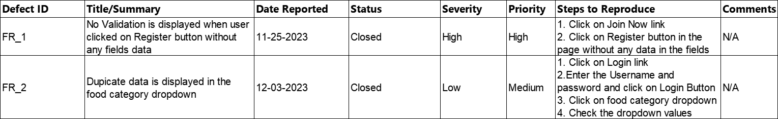

**Table No:17 Defect Report**

**7. Conclusions**

**7.1. Outcomes of the project (are all goals achieved?)**

Yes, all the goals achieved successfully and the outcomes of the Project are listed below:

New Requirements for the new website as completed as per the Plan such as Register Us Page, Login Page, and Food Review Page

**7.2. Lessons learned**

We faced the difficult while setting up the code in other machine due to different versions of tomcat and net bean, java which makes the jars update from the related websites.

**7.3. Future development**

**N/A**

**References**

[**https://github.com/siddarth58/Food-Review-SE-Project/upload**](https://github.com/siddarth58/Food-Review-SE-Project/upload)